- UK CPI inflation was a little hotter than expected in June. Some of this was due to movements in volatile components of the core category, which should unwind soon. But the broader services category showed continued stickiness. We expect CPI inflation to average 3.4% this year and 2.7% in 2026.
- We think headline inflation will edge up further over the coming months, peaking in September. Thereafter, inflation is expected to cool gradually. The positive contribution from the energy category will fade, food inflation should cool, while services inflation is expected to steadily drop as pay growth slows.
CPI inflation rose to 3.6% in June from 3.4% in May, slightly above our forecast and consensus expectations. June's modest upside surprise partly reflected larger contributions from some volatile sub-categories of core inflation, but inflation in the broader services category was also slightly stickier than anticipated. In terms of the month-to-month changes in inflation, the most notable upward pressures came from the fuel category, as the fall in petrol prices between May and June was smaller than the drop seen over the same period last year, and food prices. RPI and RPIX inflation climbed to 4.4% and 4.3% respectively in June, from 4.3% and 4.1% in May.
We now expect CPI inflation to average 3.4% this year and 2.7% in 2026. The upward pressure from volatile core goods and services sub-categories in today's release reflected a combination of base effects and one-off factors. Some of these effects should unwind in next month's data. But further base effects will mean that CPI inflation continues to edge up over the coming months, peaking in September.
After that, we expect inflation will start to drift downwards gradually. The positive contribution from the energy category should fade over the final months of this year and into 2026. Food price inflation is expected cool as the impact of a stronger pound feeds through. And though progress will be gradual, we expect services inflation will cool as pay growth continues to slow and the impact of firms passing on this year's increase in employers' national insurance contributions fades.
Chart 1: CPI inflation is forecast to average 3.4% in 2025 and 2.7% in 2026
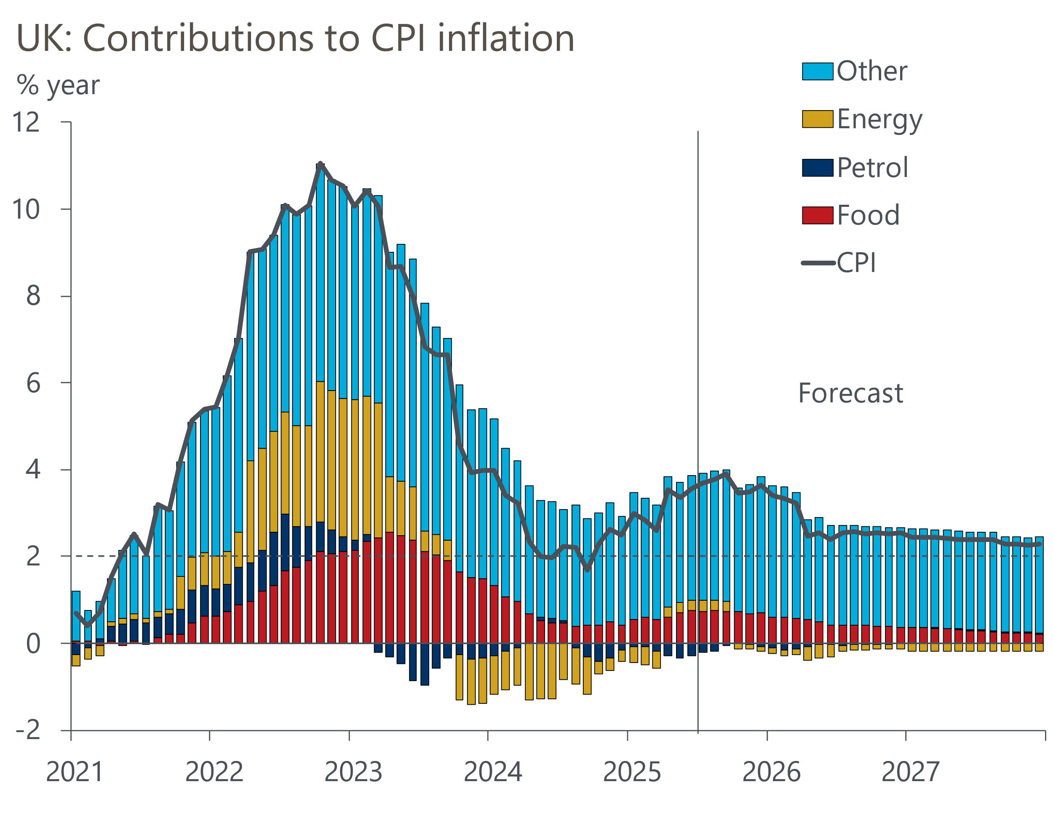
Source: Oxford Economics, Haver Analytics

